BAHRIA UNIVERSITY (KARACHI CAMPUS)

ASSIGNMENT 2

APPLIED CALCULUS AND ANALYTICAL GEOMETRY

Class: (BSE 1)
Course Instructor: (FAIZ UL HAQUE ZEYA) Time Allowed: TILL 22 nov
Date: (11TH nov ) Max Marks:10
Student’s Name: ____________________ Reg. No: _________



1.Differentiate the following
1. y = 12x5 + 3x4 + 7x3 + x2 − 9x + 6
Solution:
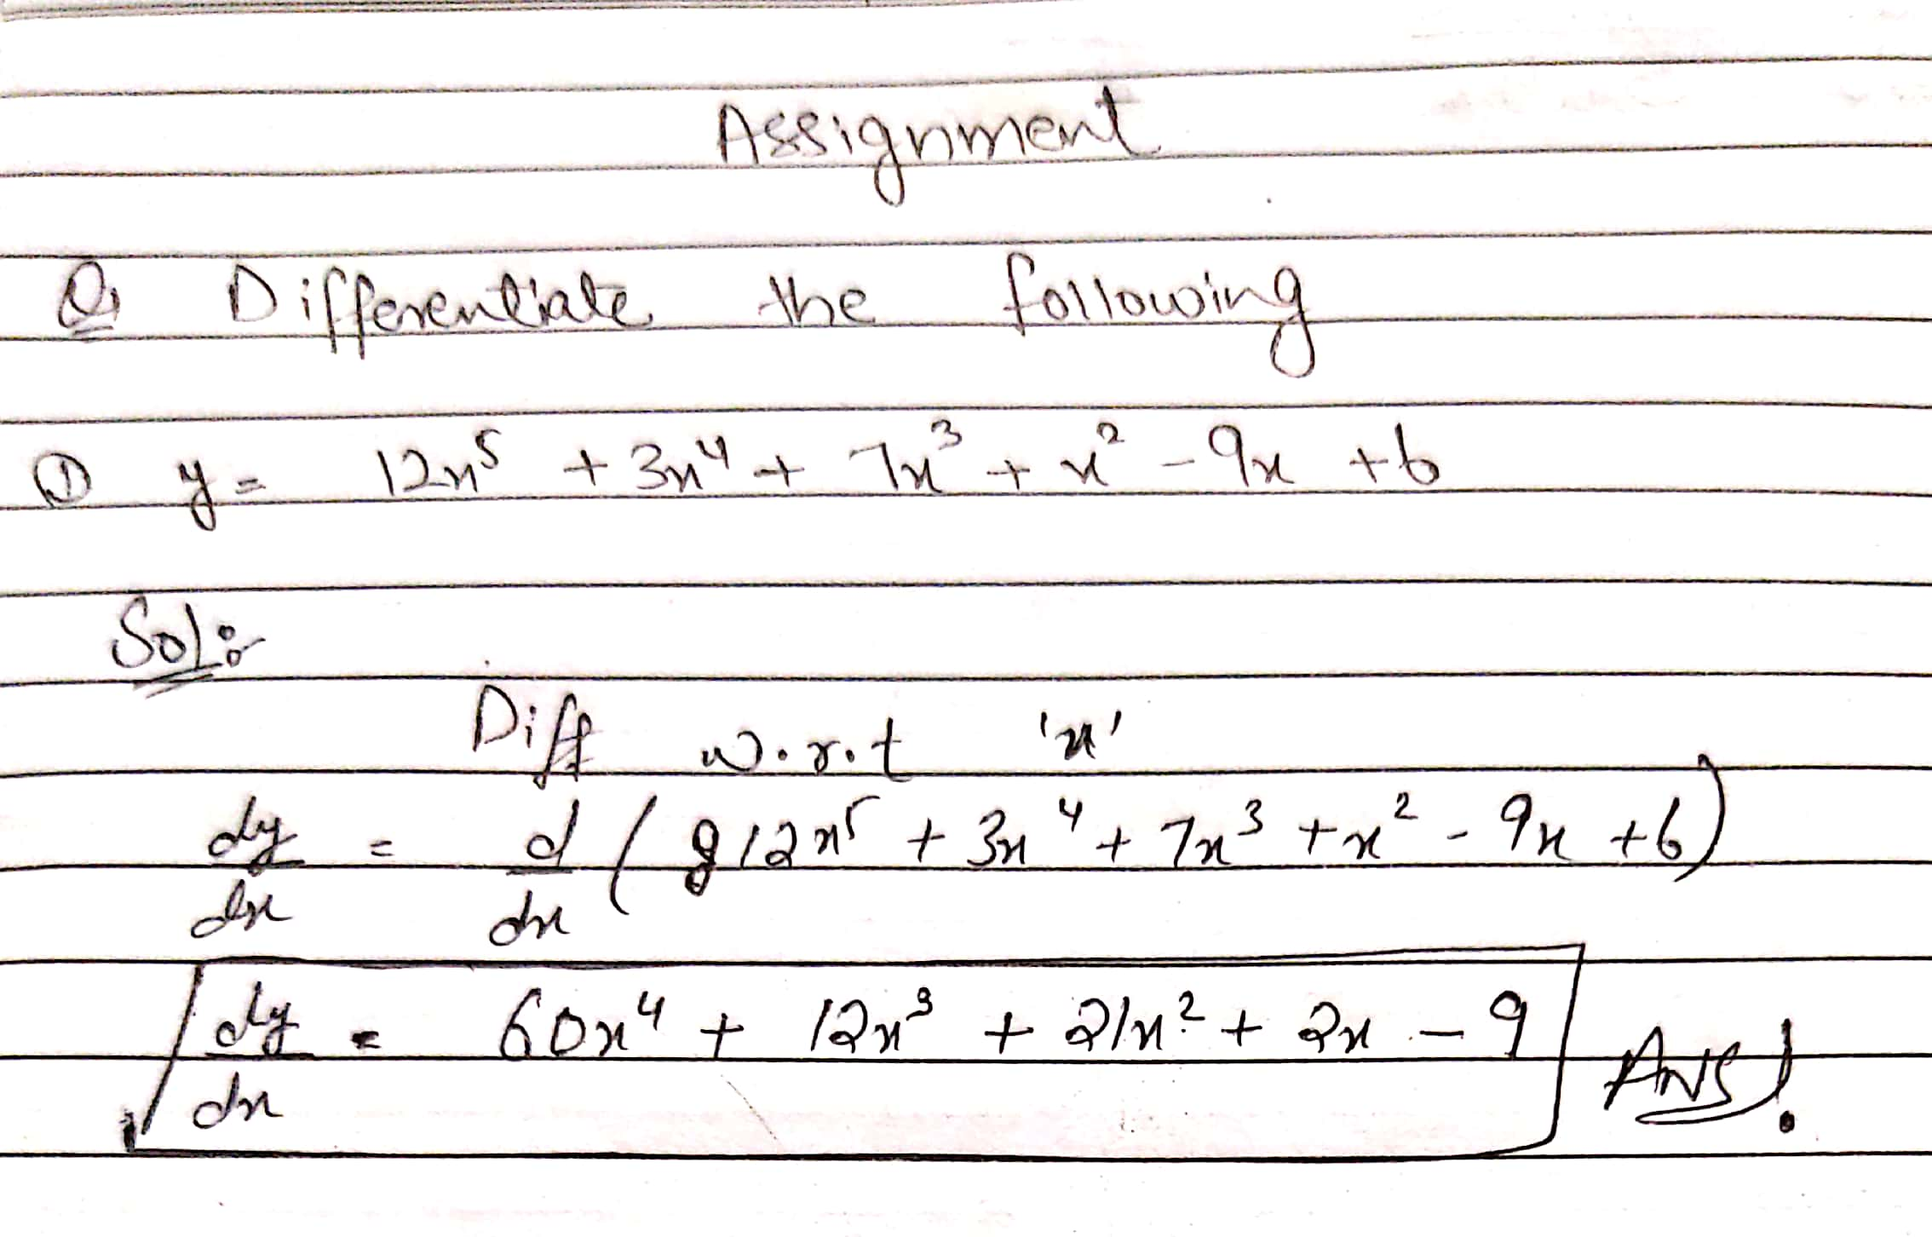
2. Y = sin (5x3 + 2x)
Solution:
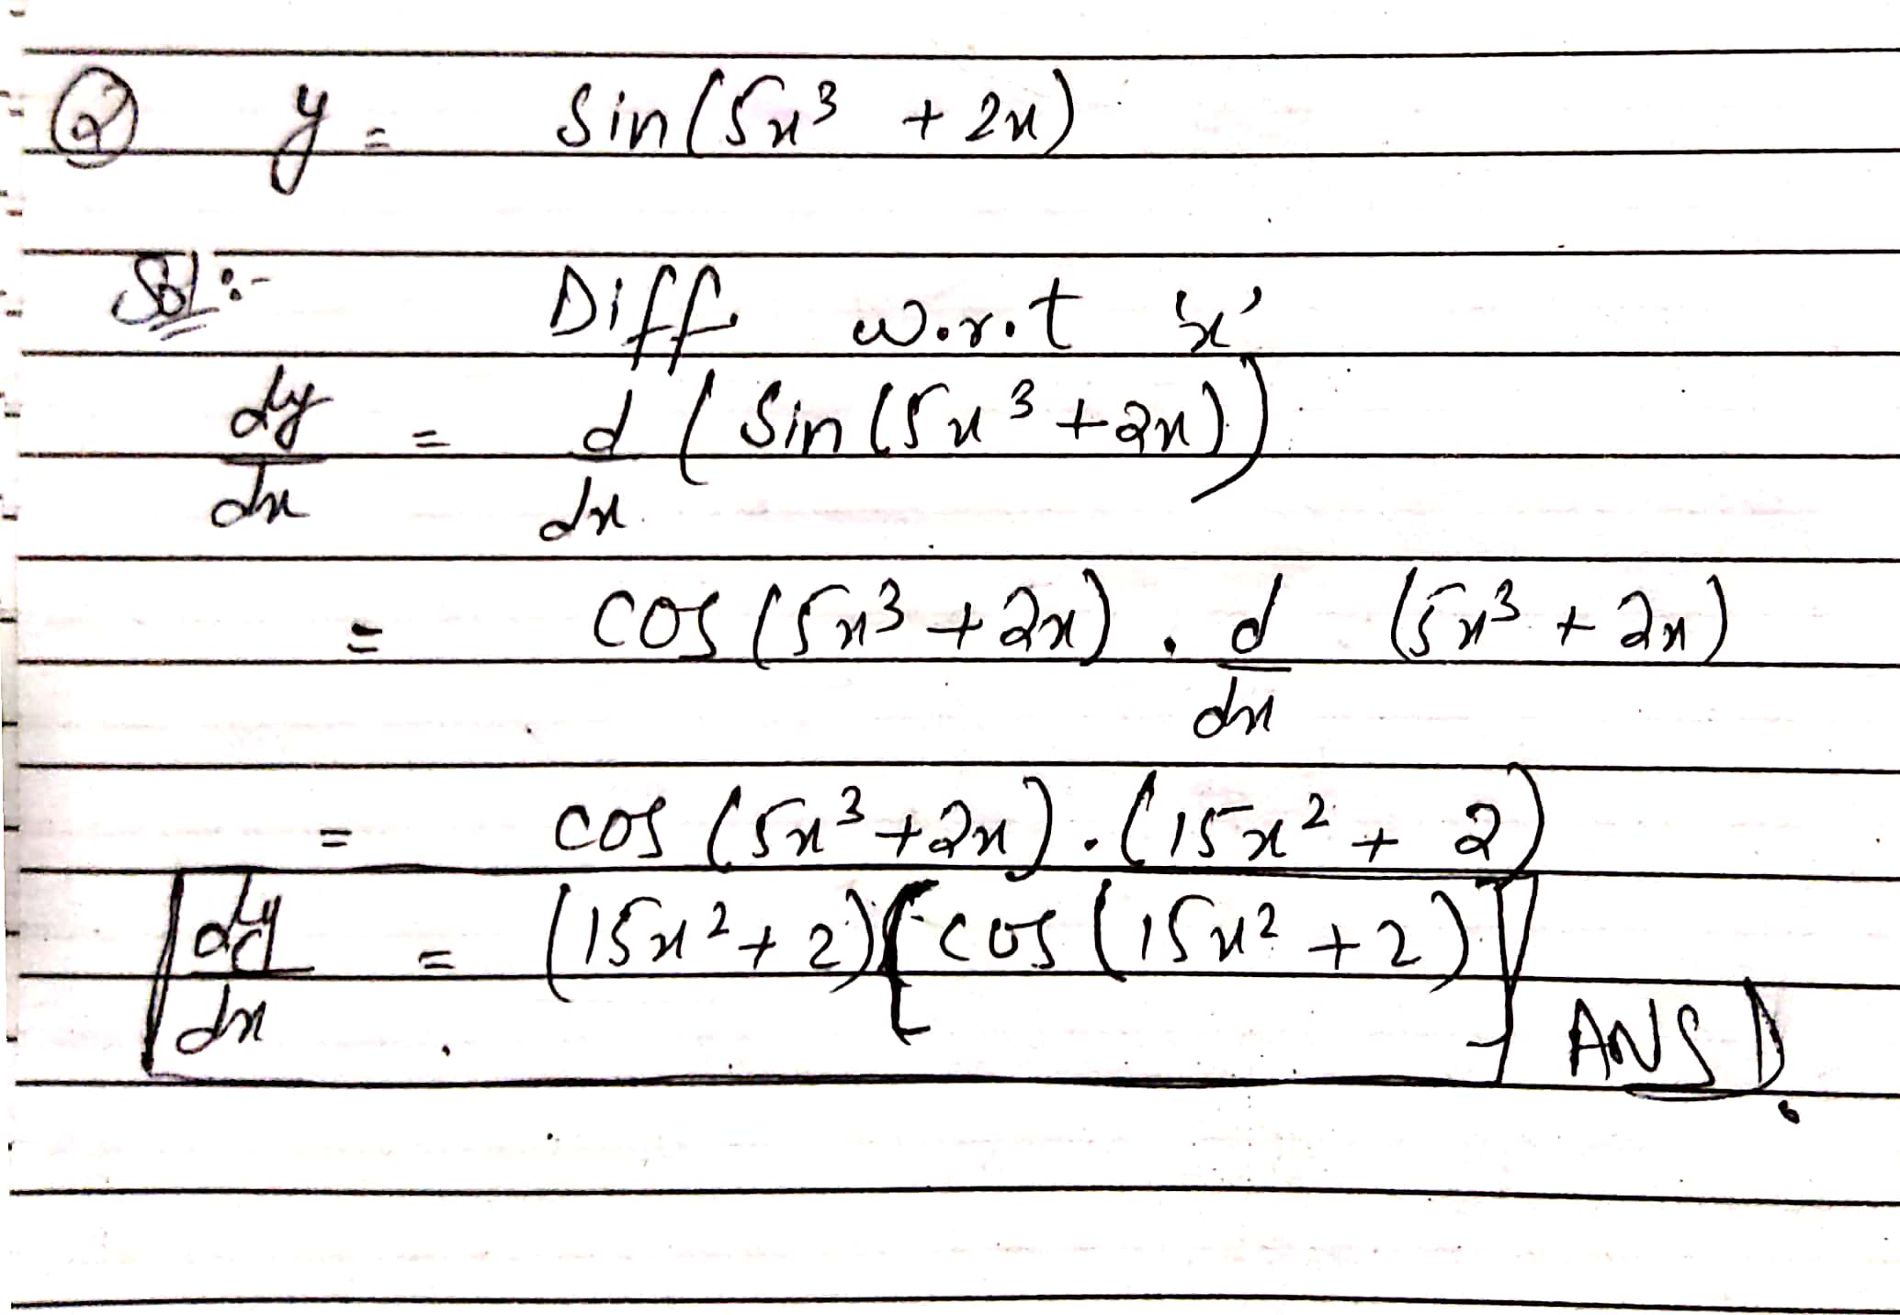
3. y = x^2sin 2x
Solution:
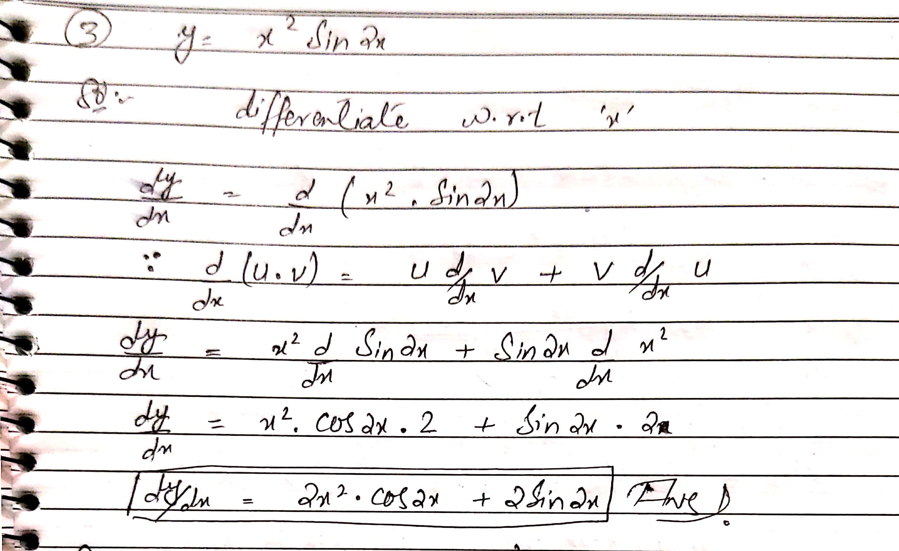
4. y = x^4(sin x3 − cos x2)
Solution:
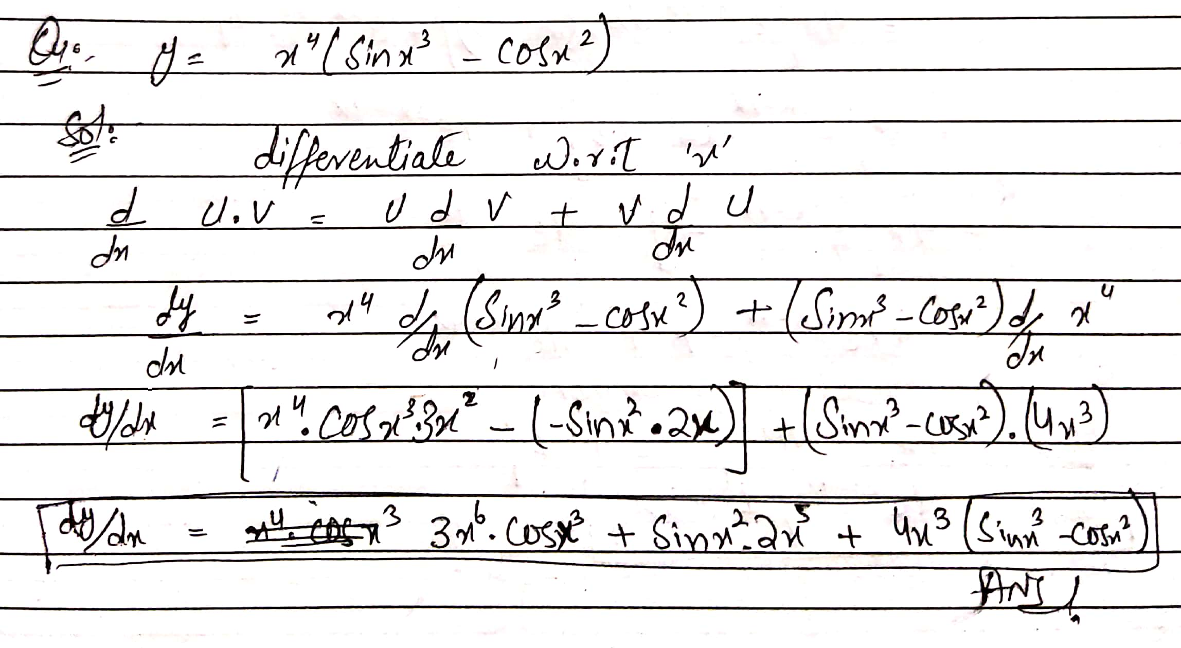
5. y = 4xe^2x − 9x
Solution:
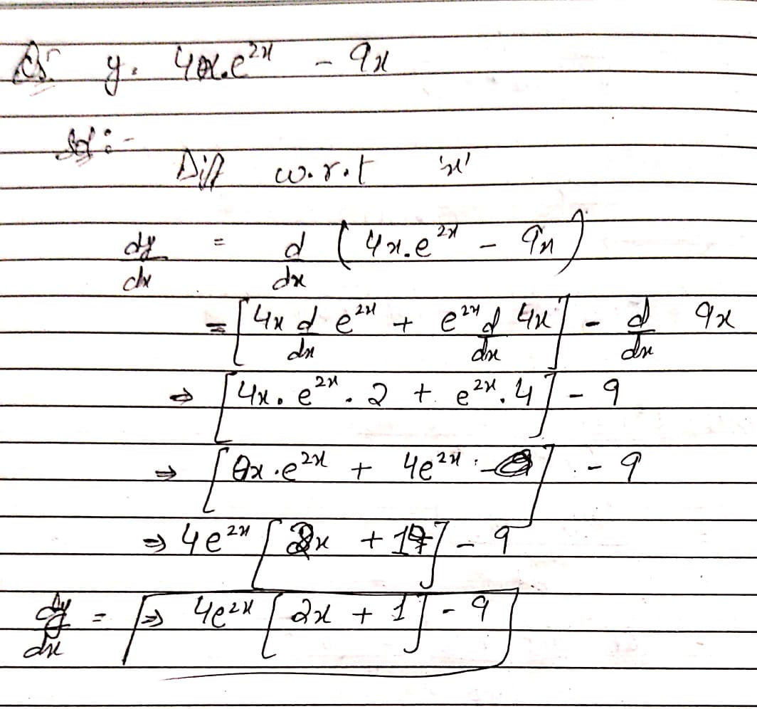
2. Find 2nd order derivative of following
1 y = 4e^xsin 5x^3
Solution:
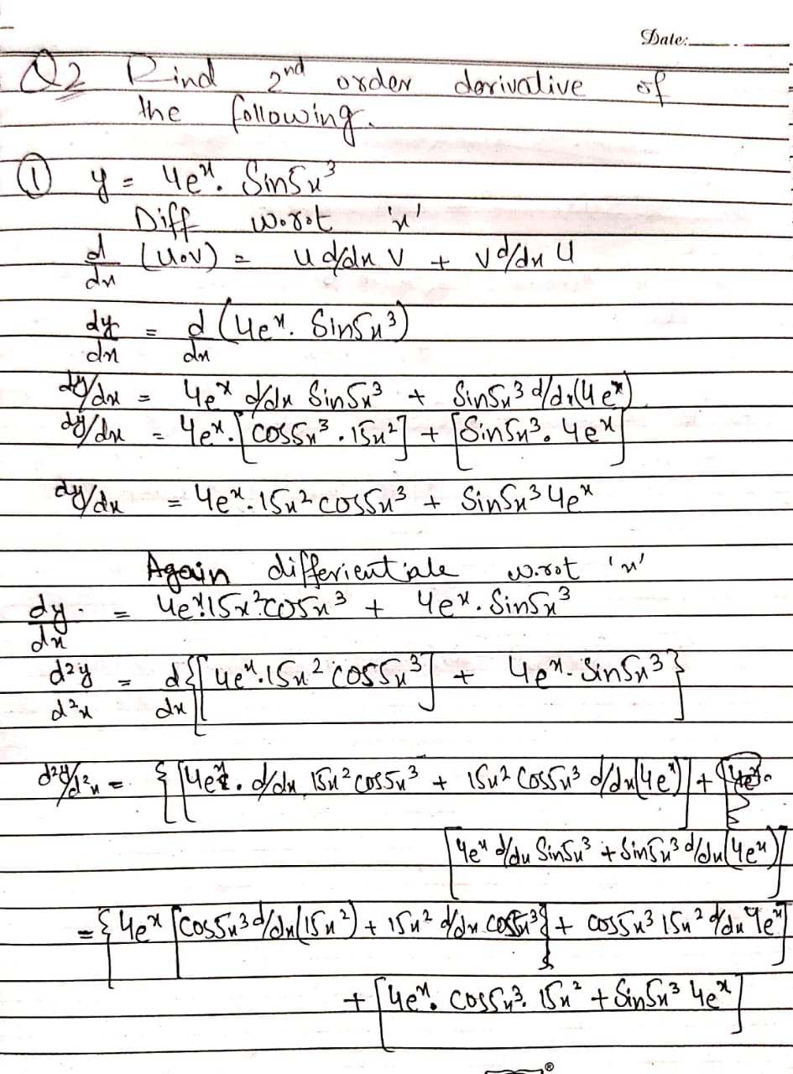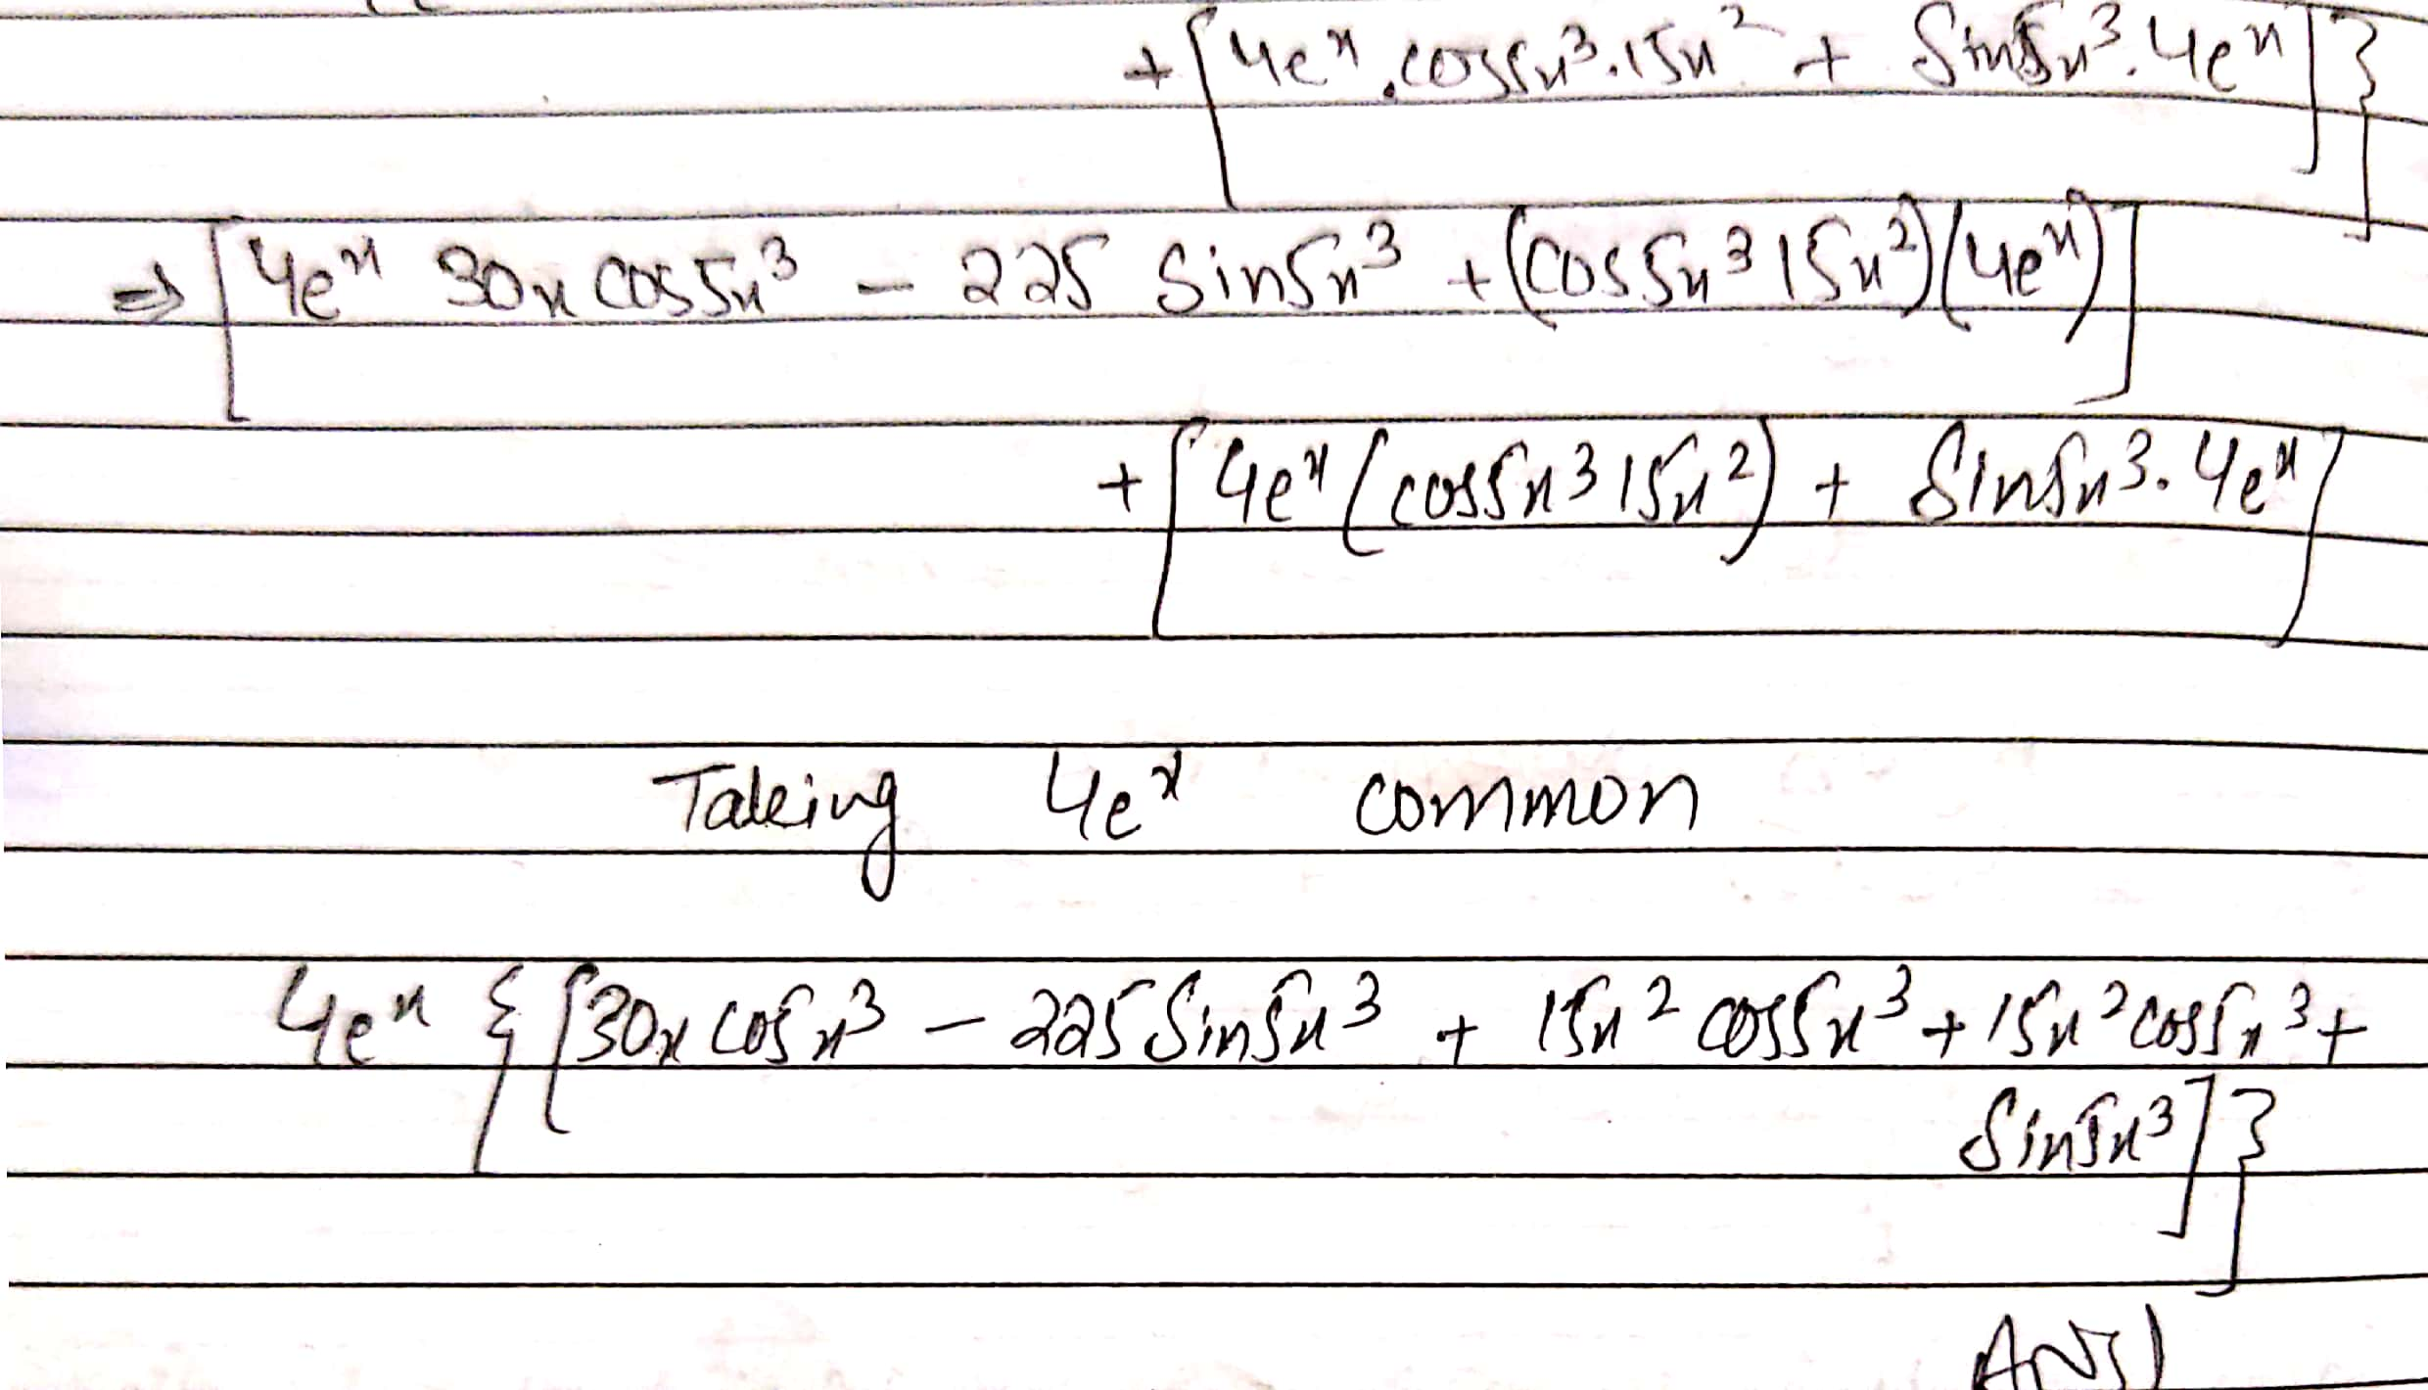
2 y = 4t^3 x=5t^2
Solution:
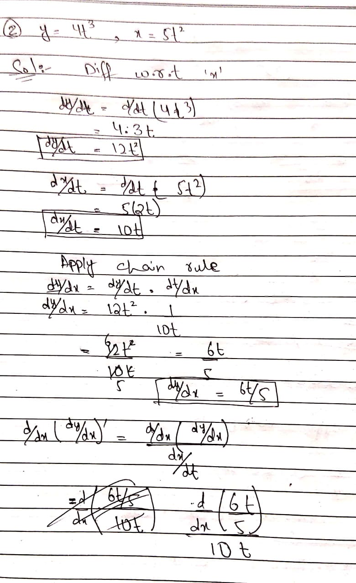

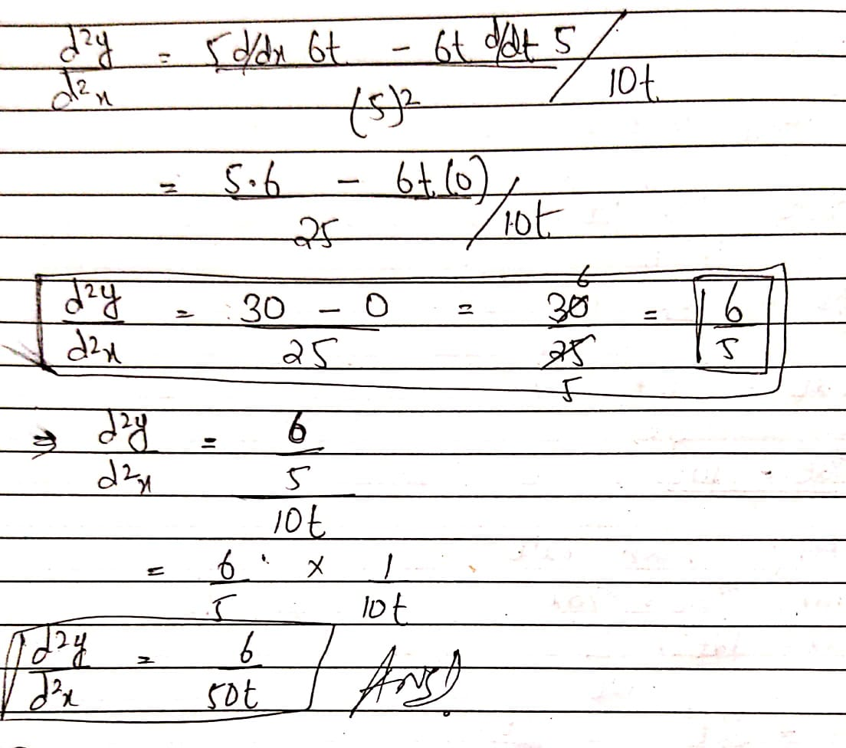

3 y = cosec 3x
Solution:
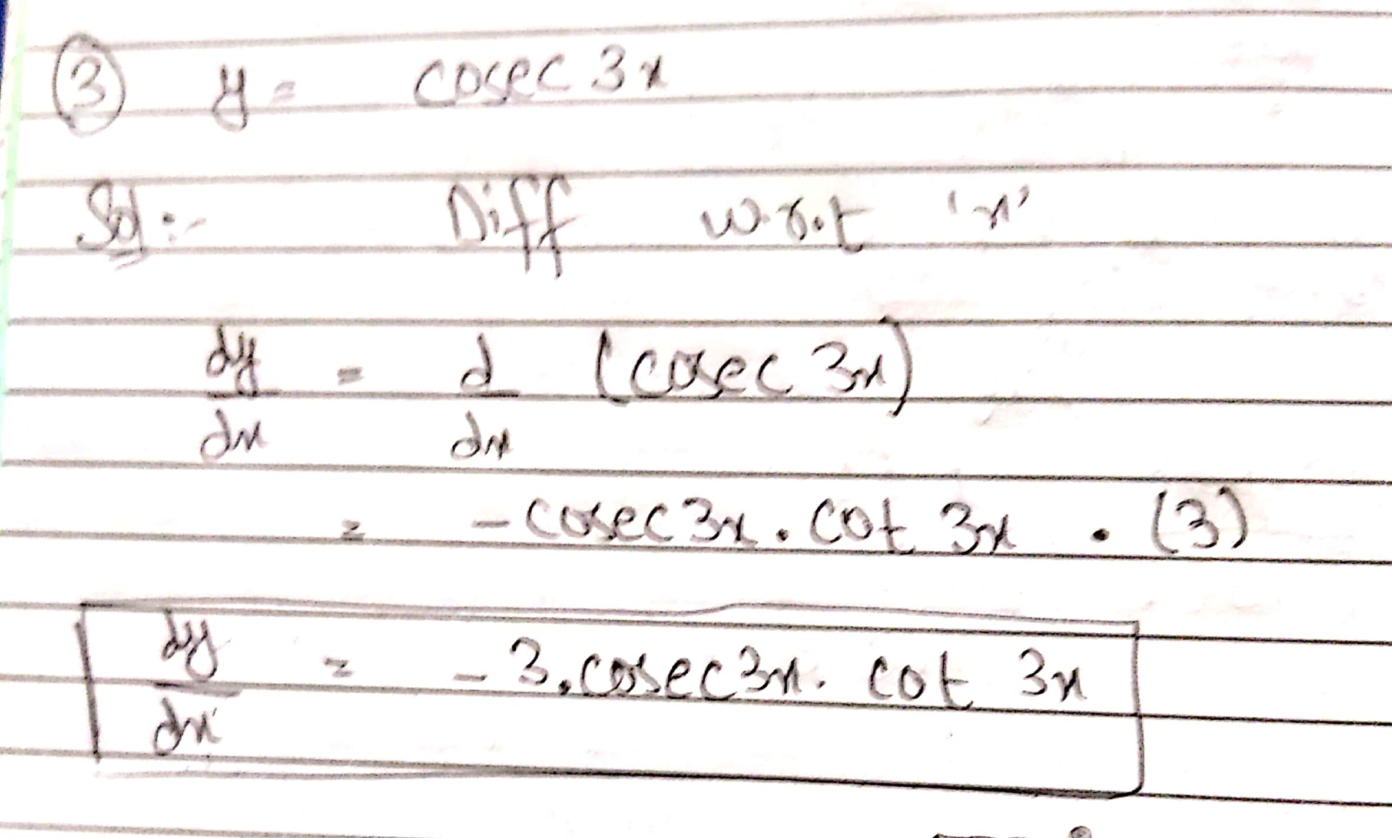
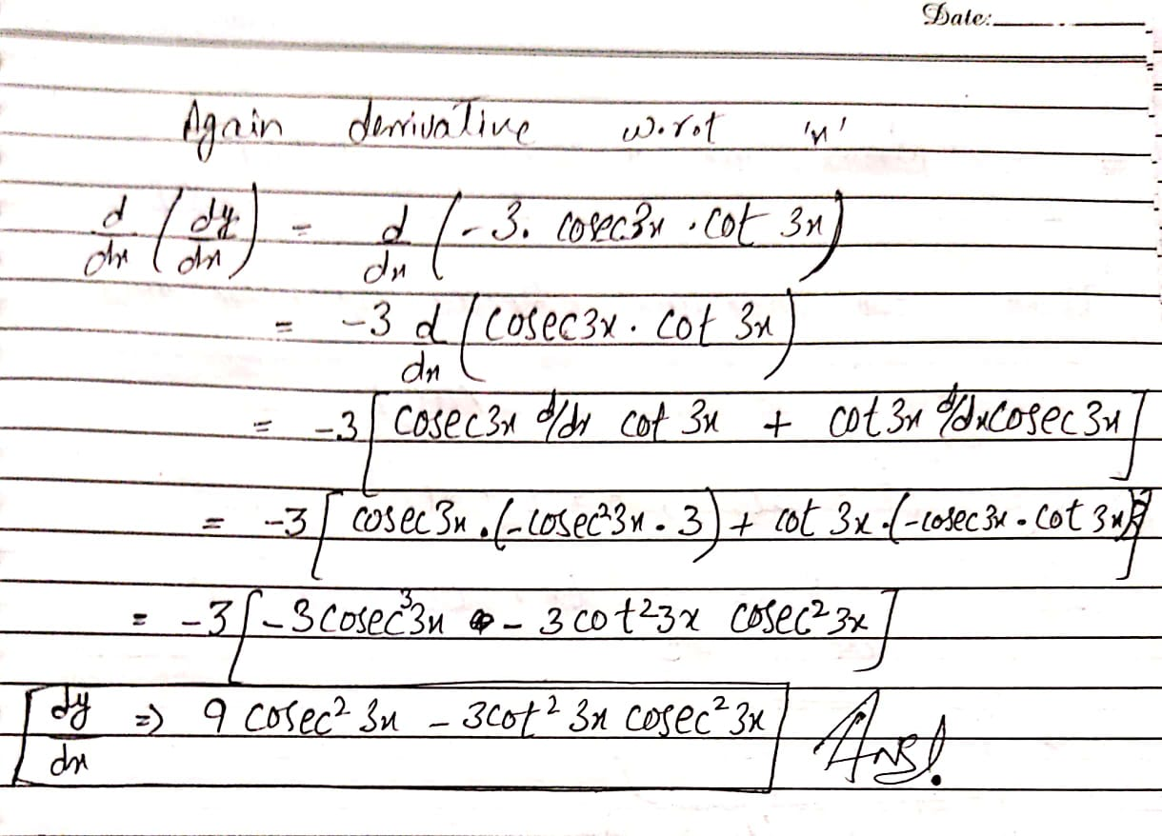
4 y= xsin2x cos x^3
Solution:
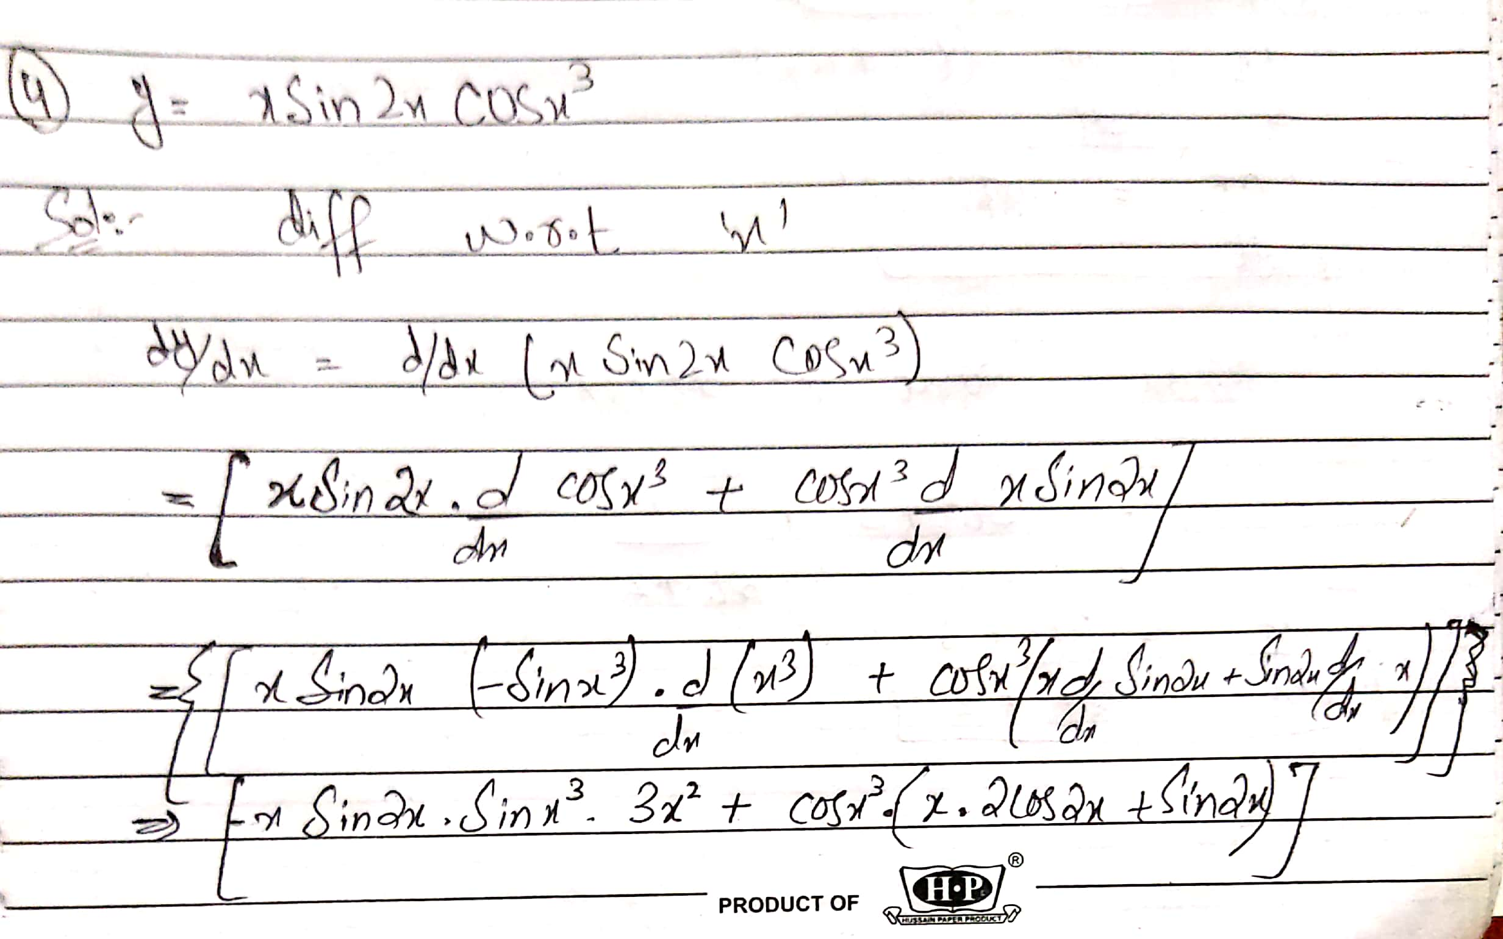
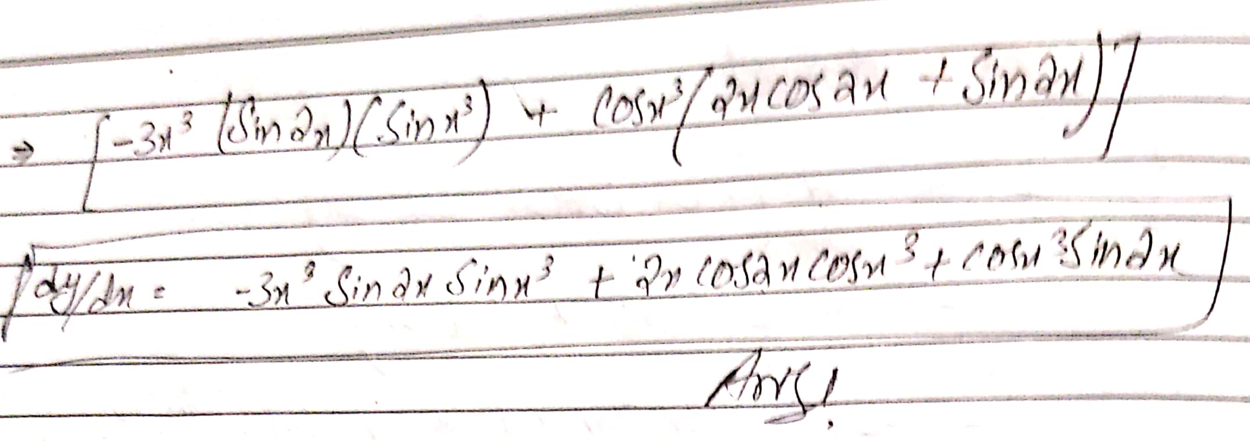
5 y=t^3 +3t x=t^2+ 2t
Solution:



